WEB SCRAPPINNG

Implementation:

I have scrapped all the data of colleges through the DTE website. For scrapping I have used BeautifulSoup library. For read url and get the HTTP response from server I have used requests, urllib, grequests libraries. For the data Visualization I have used matplotlib library of python. In the output I get the csv file which contains all data of different engineering colleges in Maharashtra. I visualise this data using piediagram. In which I have provide the percentage of no. of colleges in five regions of Maharashtra.

OUTPUT:

Here the ouput contains the percentage of no. of colleges in five regions of Maharashtra.

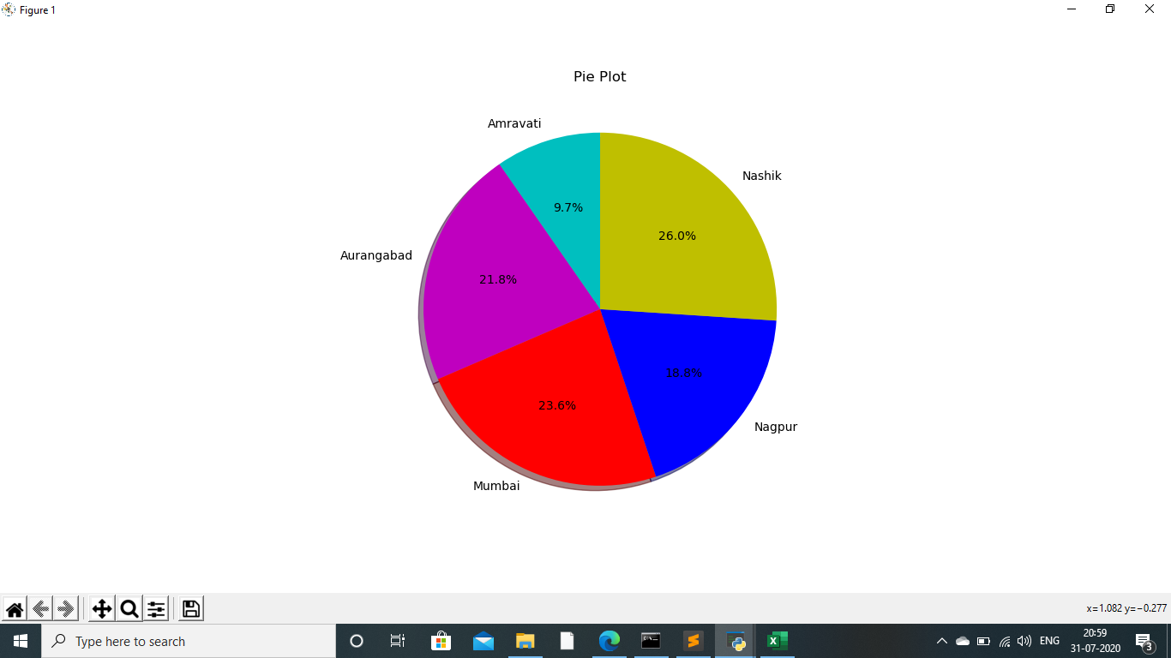

The below screenshot shows the ouput I get after running the code.

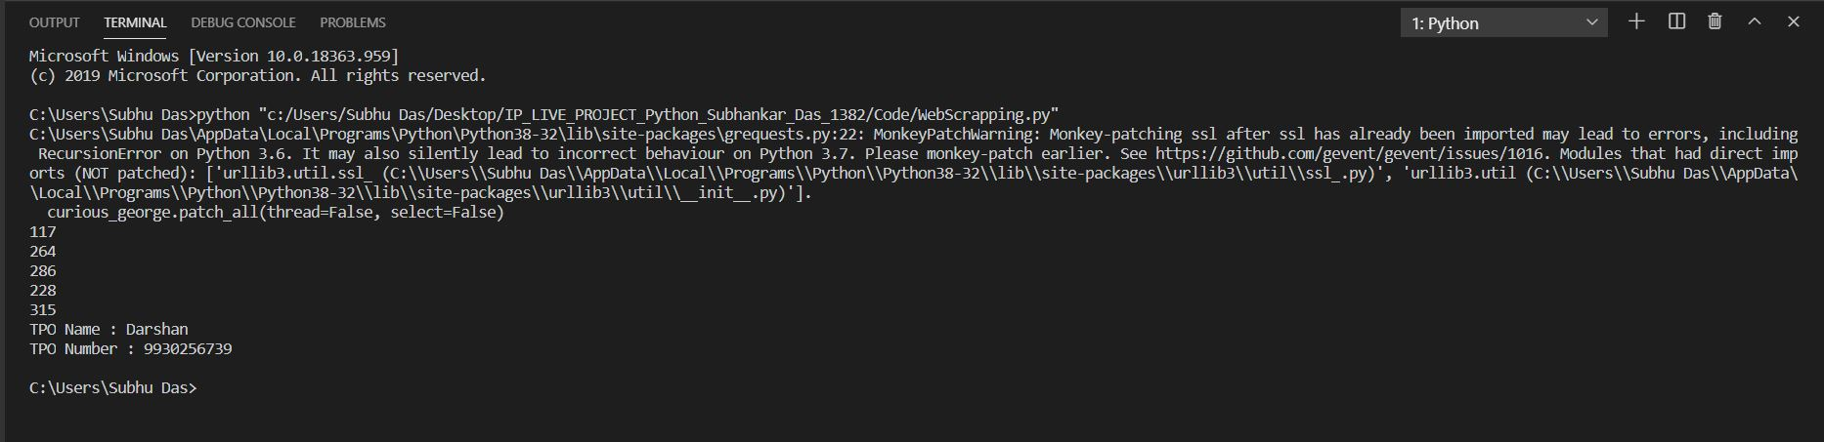

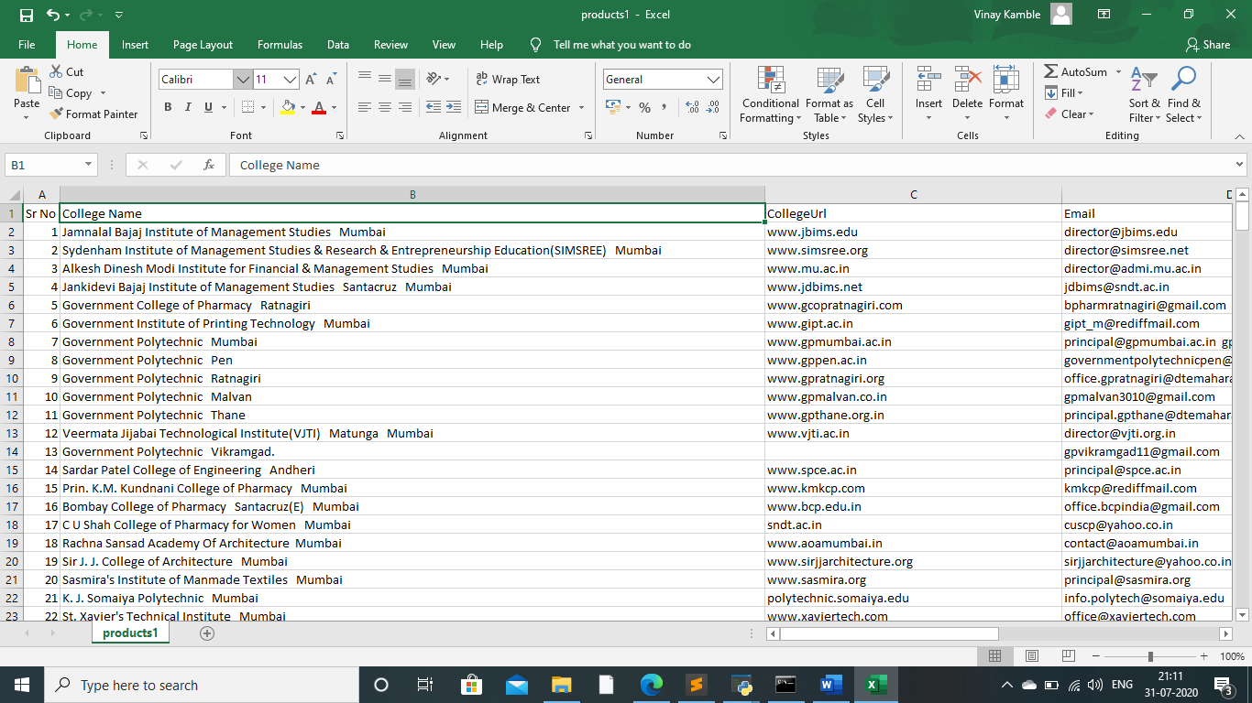Here I have provide the screenshots of csv file which I get after execution of the code.

